You are given an m x n binary matrix grid.

A **move** consists of choosing any row or column and toggling each value in that row or column (i.e., changing all 0's to 1's, and all 1's to 0's).

Every row of the matrix is interpreted as a binary number, and the **score** of the matrix is the sum of these numbers.

Return *the highest possible* ***score*** *after making any number of* ***moves*** *(including zero moves)*.

**Example 1:**

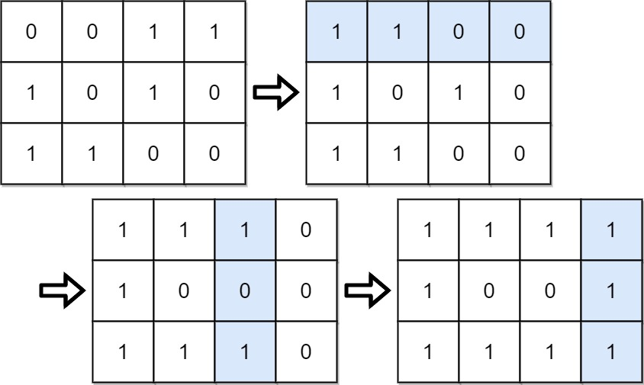

Input: grid = [[0,0,1,1],[1,0,1,0],[1,1,0,0]]  
Output: 39  
Explanation: 0b1111 + 0b1001 + 0b1111 = 15 + 9 + 15 = 39

**Example 2:**

Input: grid = [[0]]  
Output: 1

**Constraints:**

* m == grid.length
* n == grid[i].length
* 1 <= m, n <= 20
* grid[i][j] is either 0 or 1.